Software Design Document

*Treasure Box Braille Authoring Application*

EECS 2311 Group 3

# 1.0 Introduction

## 1.1 Purpose

This software design document describes the high-level organization and individual components of the *Treasure Box Braille Authoring Application*. The Authoring Application is a tool to view, edit and create scenarios for the Treasure Box Braille (TBB) device.

## 1.2 Scope

This is a PC application that functions as a workspace for users to view, edit and create TBB scenarios. The first component of the Authoring Application allows the user to create, edit and export a TBB text file. The second component can import a text file that is formatted for TBB as input and view, edit and play the scenario on a TBB for the user.

## 1.3 Definitions and Acronyms

|  |  |
| --- | --- |
| **Term** | **Definition** |
|  |  |
| PC | Personal computer |
| TBB | The Treasure Box Braille device. |
| User | Anyone using the program to view, edit or play TBB text files |

# 2.0 Design Overview

## 2.1 Description of Problem

The Braille writing system is difficult to teach to visually impaired students due its static, physical nature. The TBB device allows a dynamic and flexible way to teach students braille. The Authoring Application is an intuitive and accessible tool for teachers and educators to view, edit and create TBB scenarios, which can be then used to teach students.

## 2.2 System Organization

Figure 1 depicts the high-level organization in a class diagram.

A user opens the Authoring Application on their personal computer. The system consists of a windowed interface that will enable or disable options depending on what options are selected, that allows the user to create, import, export, edit and view TBB text files. The created or imported files can then be played back on a virtual TBB device to test them and/or saved a text file for later use.

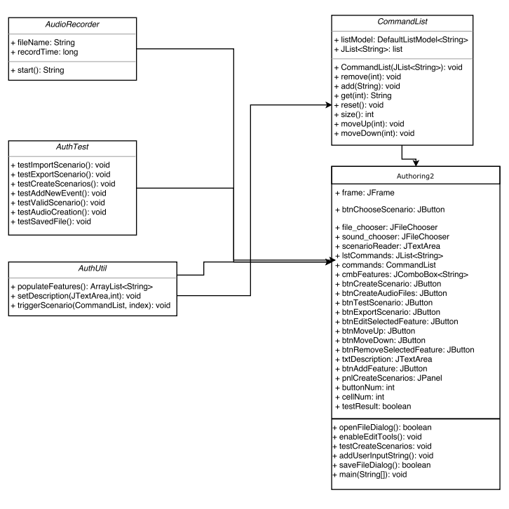

*Figure 1*

## 2.3 System Operation

Figure 2 is a typical sequence diagram for a user session.

# 3.0 System Architecture

## 3.1 System Design

Figure 3 is a block diagram below shows the different parts of the system and how they typically interact with each other.

System Interface

Create File

Export File

User

Import File

## *Figure 3*

## 3.2 Functional Decomposition

Figure 4 is a functional decomposition tree of the Authoring Application.

Authoring Application

A.2 Import Scenario

A.1 Create Scenario

A.3 Create Audio File

B.1 Test Scenario

B.1 Add Feature to Scenario

C.1 Export Scenario

*Figure 4*

# 4.0 Component Design

This section will be a break down of what each functional component of the Authoring Application does.

**A.1 Create Scenario**

* Creates a new temporary TBB scenario text file

**A.2 Import Scenario**

* Imports an existing TBB scenario text file into the workspace

**A.3 Create Audio File**

* The user must input the audio file name and length
* The system will record audio from the default microphone for the specified length and save it as a .wav file

**B.1 Add Feature to Scenario**

* User selects feature to add to scenario from drop down list
* Adds selected feature to scenario, may prompt user for input depending on which option is selected

**B.2 Test Scenario**

* Tests the imported/created scenario in a virtual TBB client

**C.1 Export Scenario**

* Exports scenario as a text file

# 5.0 User Interface Design

The Authoring Application user interface features a very clean and minimalistic layout, with user input buttons and dropdown menu on the left side of the window, and an initially blank text field on the right side, to contain the TBB text file that is created or imported.

The 10 buttons on the left side will be labelled (from top to bottom) “Create Scenario”, “Import Scenario”, “Export Scenario”, “Test Scenario”, “Create Audio File”, “Add Feature to Scenario”, “Edit Selected Feature”, “Move up”, “Move Down” and “Remove Selected Feature”.

There is one drop down menu on the centre (vertically) left side that has a variety of features that the user can add to their TBB text file.

Features that require input will have a pop up window requesting user input and/or where to save/name files.